INTERNSHIP REPORT
ON
Habit Tracker
Internship organization:

Under the guidance of
Ashwini Shetty
Lecturer, Computer Science
Submitted by
Eshaan Azeem
23BCCE025
BACHELOR OF COMPUTER APPLICATION
BCA-Cloud Computing,Cybersecurity and Ethical hacking


YENEPOYA INSTITUTE OF ARTS, SCIENCE, COMMERCE & MANAGEMENT (A constituent unit of Yenepoya Deemed to be University) Deralakatte, Mangaluru –
575018, Karnataka, India

CERTIFICATE

This is to certify that the project work entitled “Habit Tracker” has been successfully carried out at “E26 Media Production Pvt. Ltd.” by Eshaan Azeem (Reg. No. 23BCCE025), student of 3rd Year BCA(Cloud Computing,Cyber Security and Ethical Hacking). under the supervision and guidance of Ashwini Shetty, lecturer, Department of Computer Science, Yenepoya Institute of Arts, Science, Commerce and Management. This dissertation is submitted in partial fulfilment for the award of degree in Bachelor of Computer Application/Bachelor of Computer Science by Yenepoya (Deemed to be university) during academic year 2025-26.

Internal Guide: Chairperson

Internal Examiner: External Examiner

PRINCIPAL
Dr. Jeevan Raj
The Yenepoya Institute of Arts,
Science, Commerce and Management
(Deemed To be university)

Submitted for the Viva-Voce Place: Mangalore

Examination held on: Date:

DECLARATION

I, Eshaan Azeem, a student of BCA (specialization) at Yenepoya Institute of Arts, Science, Commerce, and Management, Balmatta, Mangalore, affiliated with Yenepoya (Deemed to be University), hereby declare that this internship report titled Speech Mech Neural Ecosystem is a genuine and original record of the work undertaken by me as part of my academic curriculum.
This report documents the knowledge, skills, and practical experience acquired during my internship at E26 Media PVT. LTD. It includes methodologies, analytical processes, and investigative approaches aligned with recognized industry standards in digital forensics, incident response, and cybersecurity investigations.
I extend my sincere gratitude to Mohammed Hazeem Shaim, Internship Program Head, for her/his valuable guidance, mentorship, and support throughout the internship period. I also express my appreciation to E26 Media PVT. LTD. for providing an enriching environment and exposure to real-world cybersecurity operations.
Furthermore, I acknowledge the support and encouragement received from my institutional guide, Dr Rakesh KK, and the faculty of Yenepoya Institute of Arts, Science, Commerce, and Management. Their insights and assistance have been instrumental in successfully completing this internship.

Intern Signature: Institution Guide Signature:

Name: Eshaan Azeem
Name: Ashwini Shetty
Institute: Yenepoya Institute of Arts, Science,
Date: 24/04/2026
Commerce, and Management Date:
Internship Supervisor Signature:
Head of the Department (HOD) Signature:
Name: Mohammed Hazeem Shaim Name: Dr. Rathnakar Shetty P
Head of Department of Computer Science
Designation: Institute: Yenepoya Institute of Arts, Science,
Internship Program Head Commerce, and Management
Organization:E26 Media Production Pvt. Ltd. Date: Date:

ACKNOWLEDGEMENT
I sincerely express my gratitude to Yenepoya Institute of Arts, Science, Commerce, and Management, affiliated with Yenepoya (Deemed to be University), Mangalore, for providing me with the opportunity to undertake this internship as part of my academic curriculum.
I extend my heartfelt thanks to Dr. Jeevan Raj, Principal, for his continuous support and guidance in facilitating this learning opportunity. I also express my sincere appreciation to Dr. Rathnakara Shetty P, Head of Department (Computer Science), for his encouragement and academic support throughout my internship journey.
I am deeply grateful to Ibrahim Kaleel and Mohammed Hazeem Shaim, for his visionary leadership and for fostering a dynamic learning environment in E26 Media Production Pvt.. Ltd... A special note of appreciation goes Ibrahim Kaleel, for his/her invaluable mentorship, expert guidance, and for sharing his vast experience in the field.
I also extend my sincere gratitude to the Mohammed Hazeem Shaim, for their technical insights, hands-on training, and unwavering support during my internship. Their guidance has been instrumental in enhancing my practical understanding of cyber forensics and incident response methodologies.
I am also thankful to my internal guide, Dr. Rakesh KK, for his academic mentorship and for providing valuable insights that helped bridge the gap between theoretical learning and practical application.
Lastly, I am grateful to my faculty mentors, family, and peers for their encouragement and motivation throughout this journey.
Name/Reg NO: Eshaan Azeem / 23BCCE025 Date: 24/04/2026

INTERNSHIP OFFER LETTER


INTERNSHIP COMPLETION CERTIFICATE

COMPANY PROFILE: [E26 MEDIA PRODUCTION PVT. LTD.]

E26 MEDIA PRODUCTION :
E26 Media Production is a creative media and digital content company based in Kakandy. The organization specializes in delivering high-quality and cost-effective media solutions tailored to the unique needs of clients across various industries. The company focuses on visual storytelling through video production, photography, and digital media services

Mission:
To provide high-quality and creative media solutions that meet client needs, using modern technology and innovative ideas while ensuring customer satisfaction.

Vision:
To become a leading media production company known for creativity, innovation, and excellence in digital content creation. Services Offered
- Video Production
- Website Development
- Video Editing
- Automation Service
- Mobile Application Development

Core Values:
- Customer-Centricity: Focus on client satisfaction
- Innovation: Use of new ideas and technologies
- Integrity: Honest and professional work
- Excellence: Commitment to quality and improvement
Commitment

E26 Media Production is committed to delivering professional, creative, and impactful media content while maintaining ethical practices and contributing positively to society.

Contact Information:
E26 Media Production.Pvt.Ltd
5th floor ,Shalimar Complex Near Old Ganesh Medical,
Kankanady,Mangalore-575002
Mail id-e26mediaproduction@gmail.com
Contact No: (+91 7337753124)

ROLES AND RESPONSIBILITIES

Internship Overview
During my internship in DevOps at E26 Media Production Pvt. Ltd., I had the opportunity to gain valuable hands-on experience working on real-world AI-driven projects. This internship allowed me to enhance my analytical skills, deepen my understanding of AI and ML concepts, and contribute meaningfully to the development of intelligent systems.

Apply What I've Learned:
I applied my classroom knowledge of Python, Flask, and Machine Learning to real-world projects. I worked on system integration, API development, and building AI-powered modules including NLP, RAG systems, and webhook-driven automations.

Develop AI and Automation Solutions:
I contributed to the development of the SPEECH-MECH Neural Ecosystem — a unified AI assistant platform — and the WhatsApp Delivery Gift Automation system, which sends personalized video or voice messages to gift recipients upon delivery confirmation.

Cloud Integration and Backend Development:
I gained practical experience integrating cloud services such as Azure SQL Database, Azure Blob Storage, and Pinecone Vector Database. I also worked on Flask-based REST APIs and webhook handling for real-time event-driven systems.

Work on Real Projects:
I contributed to real-time AI projects by designing modules, writing code, testing APIs, and ensuring end-toend functionality. These projects helped me understand practical applications of AI and ML in decision-making and automation.

Testing and Quality Assurance:
I was responsible for validating system modules, testing API endpoints using Postman, and debugging integration issues. I also ensured correct behavior of retry mechanisms and webhook responses.

Team Collaboration and Learning Environment:
I worked closely with mentors and team members who provided guidance and feedback, helping me understand complex concepts clearly. Through teamwork and discussions, I improved my communication, collaboration, and problem-solving skills in a professional environment.

LEARNING OUTCOMES

During my internship in Artificial Intelligence and Machine Learning, I achieved the following learning outcomes:
Strong Understanding of AI and ML Concepts:
Gained a solid foundation in AI and ML, including natural language processing, retrieval-augmented generation, model integration, and webhook-based automation.
Practical Knowledge of Development Tools:
Developed hands-on experience using Python, Flask, MySQL, Azure services, Pinecone, WhatsApp Business API, and tools such as VS Code, GitHub, and Postman.
Real-World System Building:
Learned how to design, build, and deploy complete AI-powered systems from scratch, including modular architecture design, cloud integration, and API-driven communication.
Experience in Event-Driven Architecture:
Understood how to build systems that respond to real-time events using webhooks, delivery triggers, and automated messaging pipelines.
Improved Analytical and Problem-Solving Skills:
Enhanced ability to identify issues, debug code, and design solutions for complex real-world problems using logical and analytical thinking.
Teamwork and Communication Skills:
Improved collaboration skills by working with team members and mentors, and gained confidence in presenting ideas and technical solutions.
Professional Work Experience:
Gained exposure to a professional work environment, including project handling, meeting deadlines, and continuous learning in an industry setting.

WEEKLY INTERNSHIP LOG

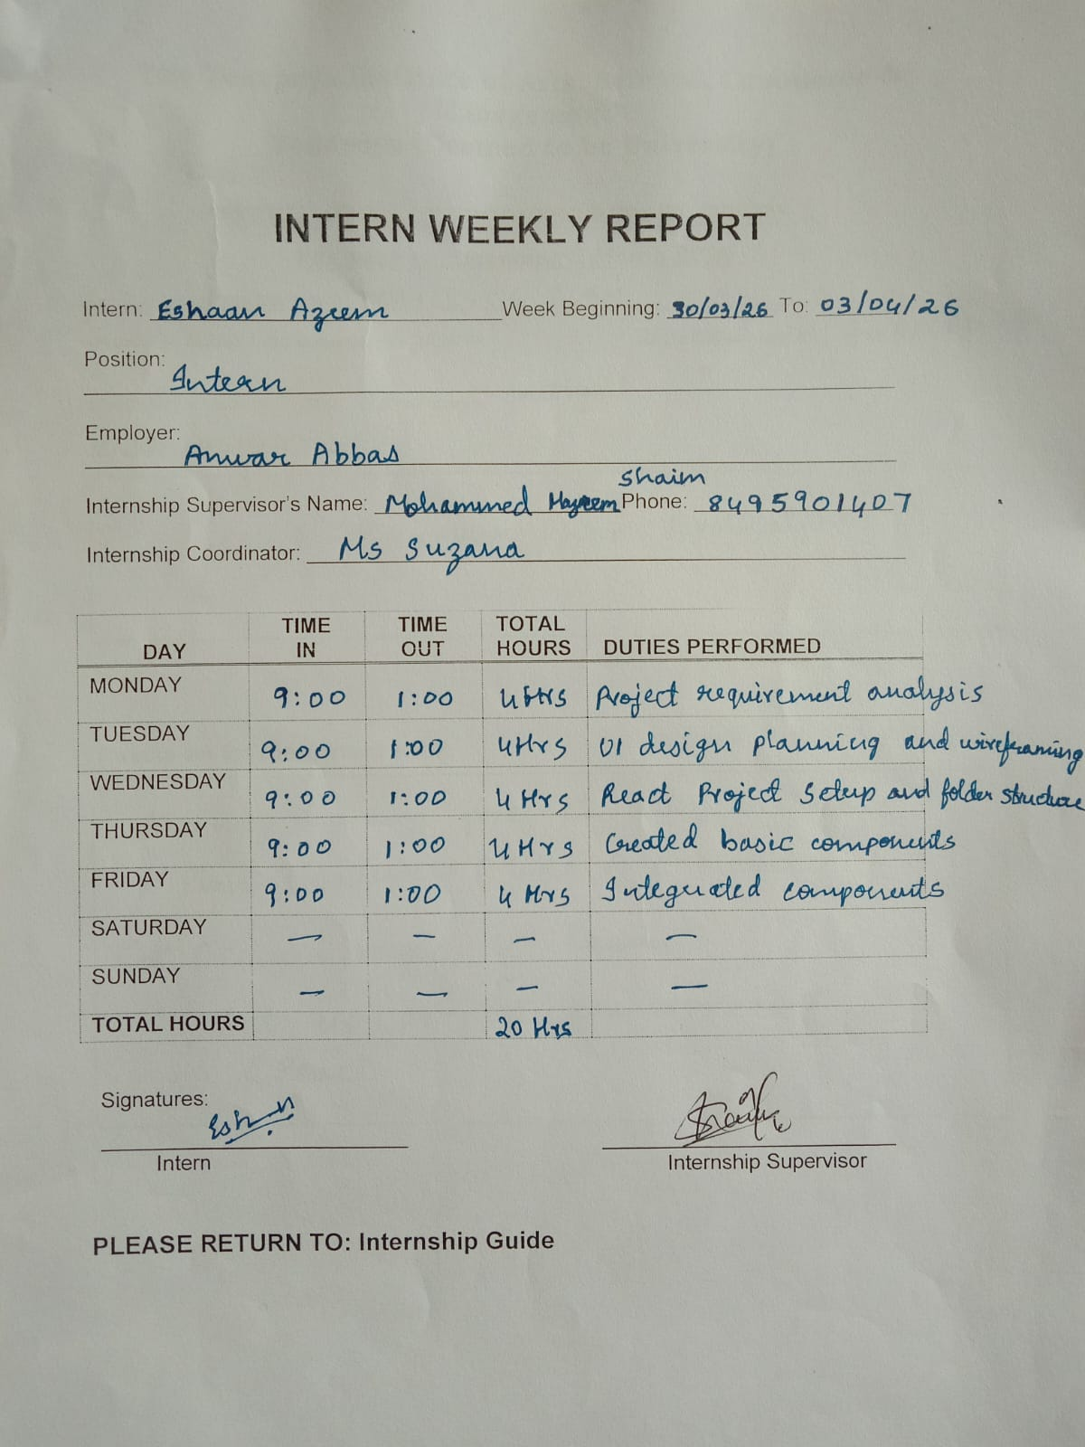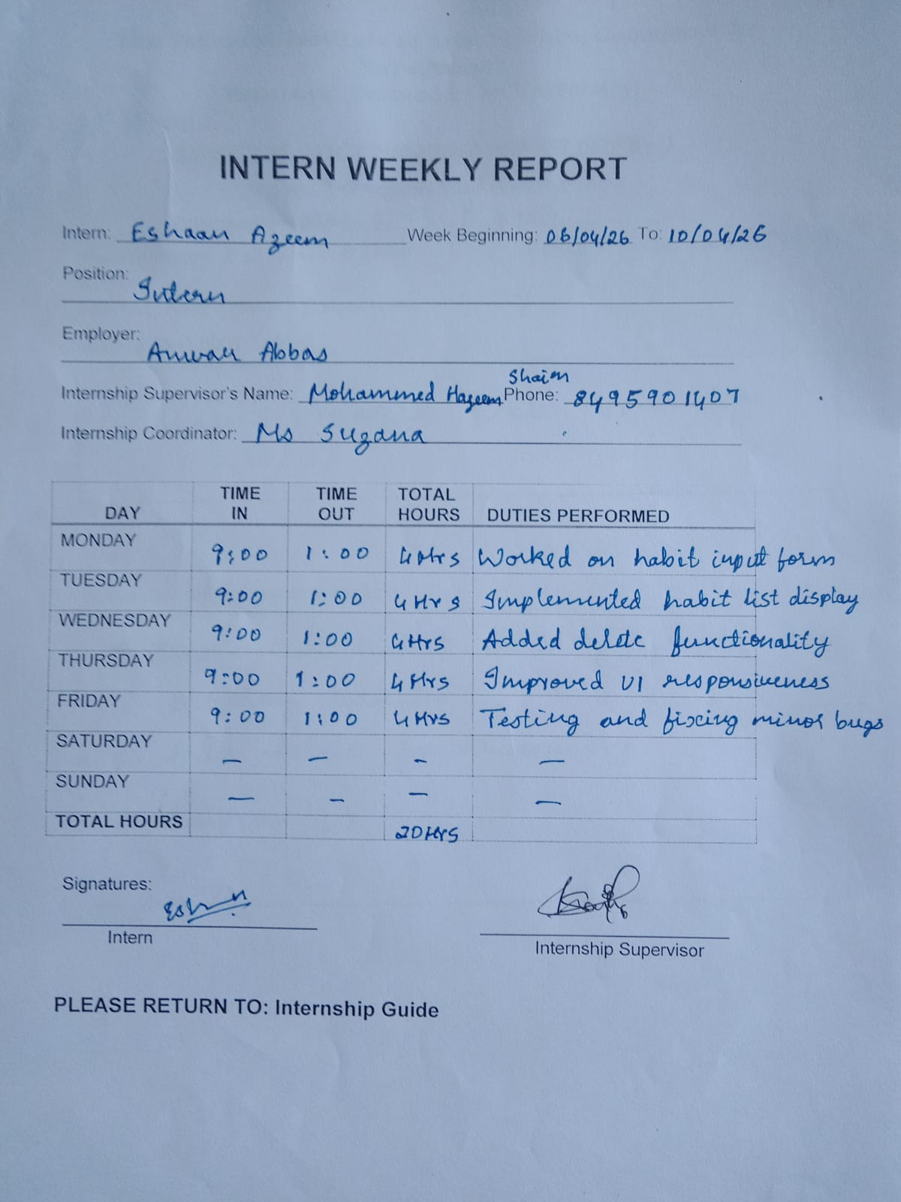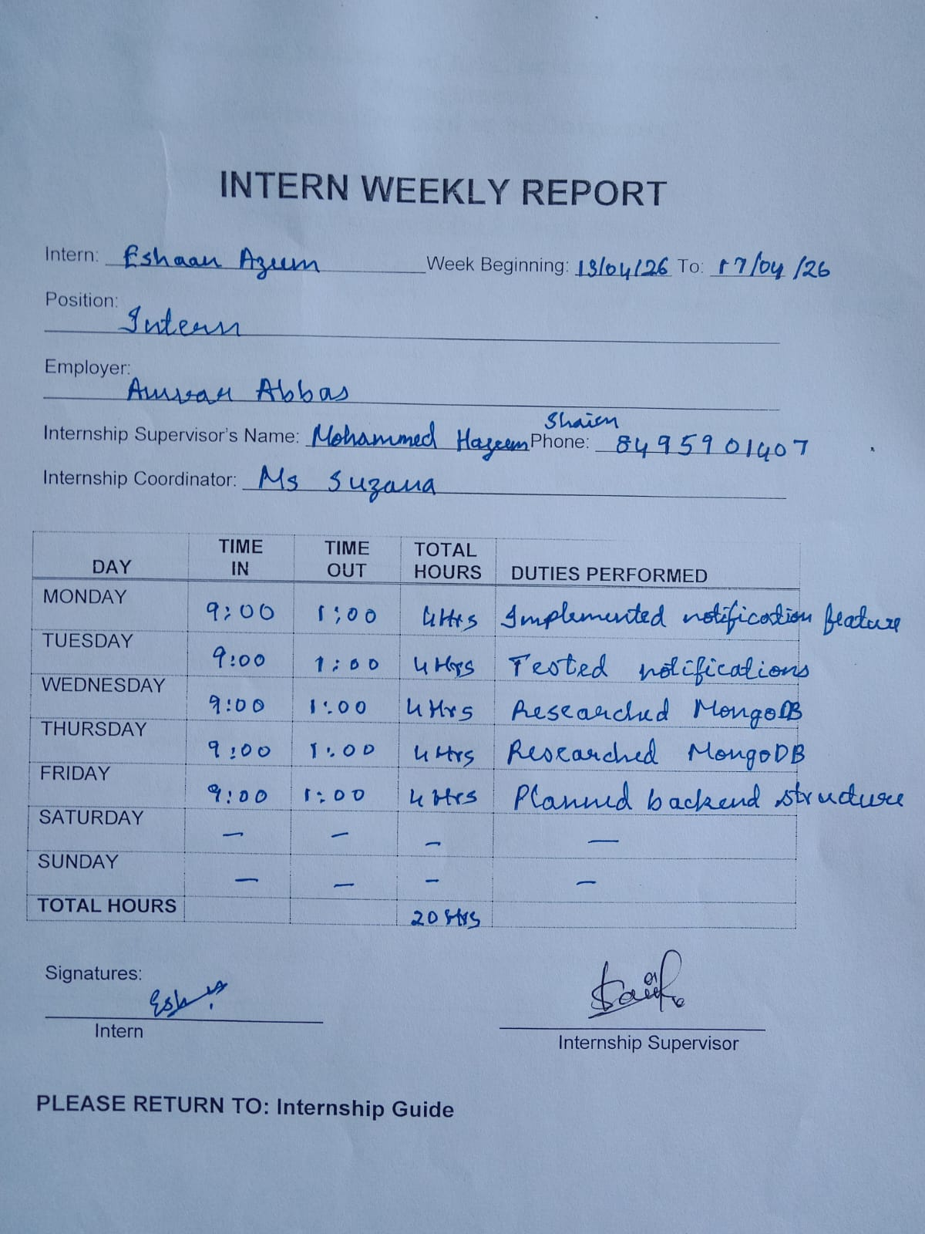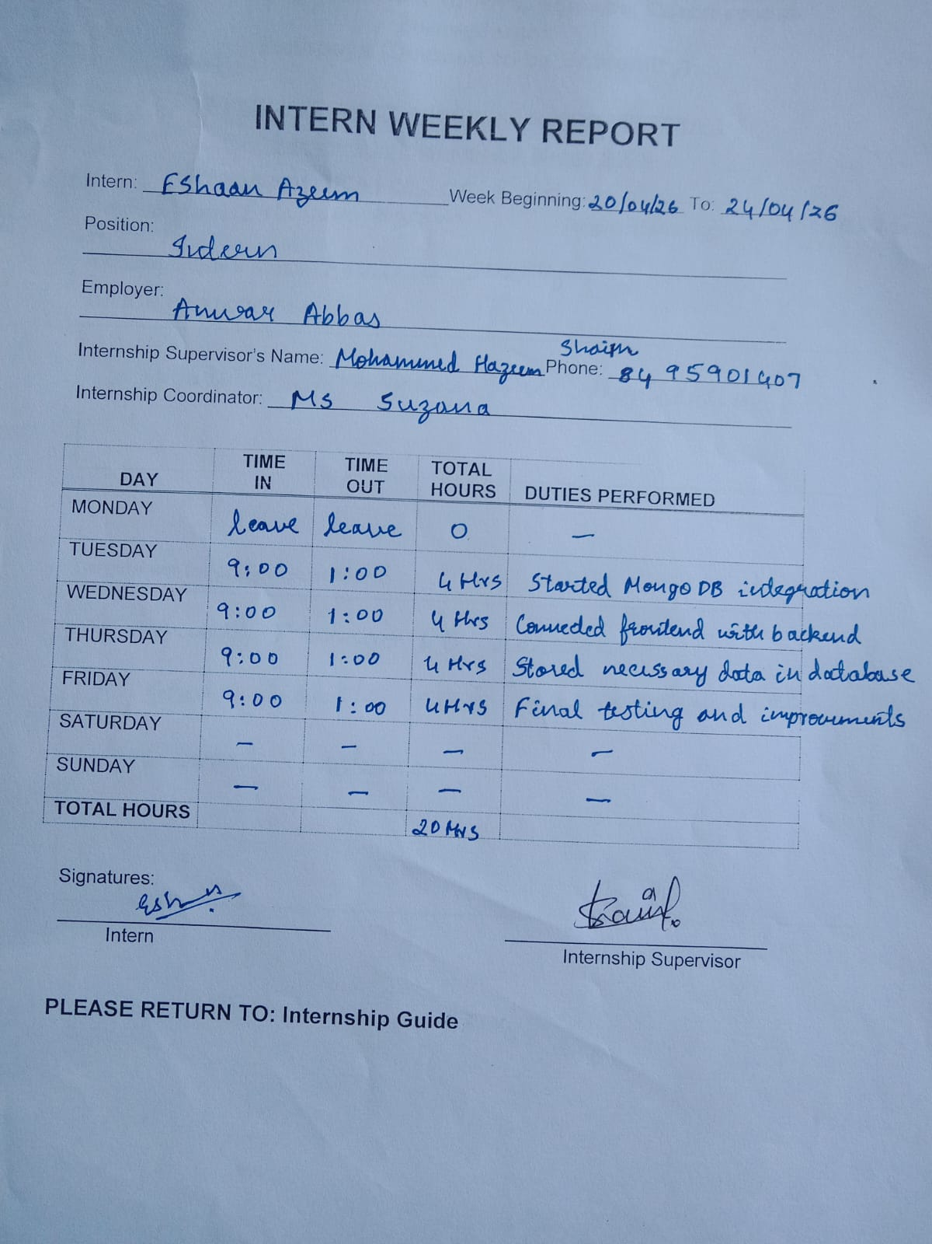

ABSTRACT
The increasing need for productivity and self-discipline in daily life has led to the development of digital systems that help individuals maintain consistency in their routines. This project, titled “Habit Tracker System”, focuses on the design and implementation of a web-based application that enables users to monitor, manage, and improve their daily habits effectively.
The system is developed using modern web technologies including React.js for the frontend, Node.js and Express.js for the backend, and MongoDB for database management. It follows a modular architecture that allows users to create habits, set reminder notifications, track daily completion status, and generate weekly progress reports.
A key feature of the system is its smart reminder and notification functionality, which helps users stay consistent by sending timely browser notifications. The system also includes a timeout-based reminder mechanism that ensures notifications remain active until user interaction, improving accountability and reducing missed habits.
Additionally, the application securely stores user habit data, reminder schedules, and completion history using MongoDB, allowing long-term progress tracking and performance analysis. Features such as notification history, habit streak monitoring, and progress visualization further enhance user engagement and productivity.
The project demonstrates the practical implementation of a simple yet effective productivity management system that supports personal development through habit formation. It highlights how technology can be used to build discipline, improve time management, and promote a more organized lifestyle through consistent habit tracking.

Table of contents
Sl.No | Topic | Page No
1 | CHAPTER 1: INTRODUCTION | 20
1.1 | Background | 20
1.2 | Objectives | 20
1.3 | Purpose | 21
1.4 | Scope | 21
1.5 | Data Sources | 22
1.6 | Problem Definition | 22
2 | CHAPTER 2: TOOLS AND TECHNOLOGY USED | 24
2.1 | Programming Language | 24
2.2 | Web Framework | 24
2.3 | Cloud Technologies | 25
2.3.1 | Azure SQL Database | 25
2.3.2 | Azure Blob Storage | 25
2.4 | Vector Database (Pinecone) | 25
2.5 | Artificial Intelligence Technologies | 25
2.5.1 | Natural Language Processing | 25
2.5.2 | Large Language Models | 26
2.6 | User Interaction and Speech Interface | 26
2.6.1 | Text-Based Interaction | 26
2.6.2 | Voice Interaction (Web Speech API) | 26
2.6.3 | Advantages of the Approach | 26
2.7 | Computer Vision | 27
2.8 | Document Processing | 27
2.9 | Image Generation | 27
2.10 | Development Tools | 28
2.11 | Summary | 28
3 | CHAPTER 3: DATA COLLECTION AND ANALYSIS | 29
3.1 | Data Collection | 29
3.2 | Data Preprocessing | 29
3.3 | Feature Engineering | 30
3.4 | Exploratory Data Analysis | 31
3.5 | Data Flow in the System | 31
3.6 | Summary | 32
4 | CHAPTER 4: SYSTEM REQUIREMENTS AND ANALYSIS | 33
4.1 | System Requirements Specification | 33
4.1.1 | Functional Requirements | 33
4.1.2 | Non-Functional Requirements | 34
4.2 | Hardware and Software Requirements | 35
4.3 | System Overview | 35
4.4 | Summary | 36
5 | CHAPTER 5: IMPLEMENTATION | 38
5.1 | System Design and Architecture | 38
5.2 | Workflow and Process Description | 39
5.3 | Module Description | 40
5.3.1 | Launcher Module | 40
5.3.2 | Web Server Module | 40
5.3.3 | Authentication Module | 40
5.3.4 | AI P5.3rocessing Module | 42
5.3.5 | RAG Module | 42
5.3.6 | Omni Coder Module | 43
5.3.7 | Media System Module | 43
5.3.8 | Image Generation Module | 46
5.3.9 | Command Routing Module | 46
5.3.10 | Cloud Integration Module | 47
5.4 | System Integration | 48
5.5 | Advantages of Implementation | 48
5.6 | Remote Access using ngrok | 48
5.7 | Summary | 49
6 | CHAPTER 6: FUTURE SCOPE AND CONCLUSION | 50
6.1 | Future Scope | 50
6.2 | Conclusion | 50
7 | CHAPTER 7: BIBLIOGRAPHY | 52

CHAPTER 1: INTRODUCTION
1.1 Background
In the modern world, maintaining a balanced and disciplined lifestyle has become increasingly difficult due to busy schedules, distractions, and poor time management. Many people begin habits such as exercising regularly, reading books, studying consistently, offering prayers on time, drinking enough water, or maintaining proper sleep routines, but often fail to continue them for long periods. The main reason behind this failure is the lack of consistency, reminders, and proper progress monitoring.
Traditionally, people used notebooks, diaries, calendars, or manual checklists to keep track of their habits. Although these methods are simple, they are not highly effective because they require constant manual effort, can be easily forgotten, and do not provide automatic reminders or progress analysis. As a result, users often lose motivation and fail to maintain discipline.
With the advancement of web technologies, digital habit tracking systems have become a practical solution to this problem. A web-based habit tracker provides users with automation, reminders, notifications, progress reports, and data storage, making the process much easier and more reliable.
The Habit Tracker System developed in this project is designed to help users build positive routines and improve personal productivity. It allows users to add habits, set reminder timings, receive browser notifications, track completion status, monitor weekly progress, and maintain notification history. By using this system, users can improve accountability, reduce forgetfulness, and achieve long-term consistency in their personal goals.
This project combines frontend development, backend integration, browser notification systems, and MongoDB database management to create a complete productivity-focused application that supports self-improvement through regular habit monitoring.

1.2 Objectives
The Habit Tracker System is developed with the goal of improving daily productivity and helping users maintain consistency in their routines. The project focuses on providing a simple and efficient platform for monitoring personal habits and encouraging discipline through regular tracking.
The major objectives of the project are:
- To develop a web-based system for tracking daily habits and routines
- To help users maintain consistency in important activities such as exercise, study, prayer, reading, and health-related habits
- To provide reminder notifications at scheduled times to reduce forgetfulness
- To allow users to mark habits as completed and monitor their daily performance
- To calculate habit streaks and completion percentages for motivation
- To generate weekly progress reports for performance analysis
- To store habit details, reminder timings, and completion history securely using MongoDB
- To provide a user-friendly and responsive interface for better usability
- To improve time management, self-discipline, and personal development
These objectives ensure that the system acts as both a productivity tool and a self-improvement platform for users.

1.3 Purpose
The main purpose of developing the Habit Tracker System is to provide users with an efficient digital platform that helps them build and maintain good habits consistently. In many cases, individuals fail to follow their routines not because of lack of intention, but because of forgetfulness, poor planning, and lack of motivation. This project aims to solve these issues through smart reminders and continuous progress monitoring.
The system is designed to make habit tracking simple, accessible, and practical for everyday use. Instead of depending on manual methods such as notebooks or calendars, users can manage all their habits in one place through an interactive web application. This improves convenience and saves time.
Another important purpose of the project is to demonstrate the practical implementation of modern web development technologies such as React.js, Node.js, Express.js, browser notifications, and MongoDB database integration. It provides real-world experience in frontend design, backend development, database management, and system integration.
The project also serves an educational purpose by helping developers understand how productivity applications are designed and implemented in real-world environments. Overall, the system aims to improve personal discipline while providing technical learning opportunities through software development.

1.4 Scope
The scope of the Habit Tracker System mainly focuses on personal habit management and productivity improvement. The system is designed for individuals who want to monitor and improve their daily routines in a simple and organized manner.
The current scope of the project includes:
- Creating and managing daily habits
- Setting reminder notifications for each habit
- Receiving browser alerts at scheduled times
- Tracking habit completion status
- Maintaining daily and weekly performance records
- Generating weekly reports for progress analysis
- Monitoring notification history
- Calculating consistency streaks
- Storing all data securely using MongoDB
The system is suitable for students, working professionals, fitness enthusiasts, and anyone who wants to improve discipline and routine management.
The project is currently designed as a web-based application that runs in browsers. However, the future scope can be expanded to include:
- Mobile application development for Android and iOS
- AI-based habit recommendations
- Cloud synchronization across devices
- Gamification features such as rewards and badges
- Social sharing and accountability groups
- Multi-user support with personalized dashboards
- Advanced analytics and productivity charts
This wide scope makes the Habit Tracker System a scalable and highly useful project for long-term development.

1.5 Data Sources
The Habit Tracker System depends on user-generated data for its functioning. Since the project focuses on personal productivity, most of the data is directly entered and managed by the user.
The primary data sources include:
User Input Data
This includes habit names, categories, descriptions, and reminder timings entered by users manually.
Examples:
- Exercise
- Reading
- Prayer
- Study Time
- Water Intake
Reminder Data
The system stores scheduled notification times for each habit so that alerts can be triggered automatically at the correct time.
Completion Records
Each time a user marks a habit as completed, the system records the completion status along with the date and time for progress tracking.
Weekly Progress Logs
The system maintains summary records of completed and missed habits during the week to generate weekly reports.
Notification History
All reminder notifications triggered by the system are stored to allow users to review missed or completed reminders later.
Streak Data
The system calculates continuous completion streaks for each habit, helping users stay motivated and consistent.
All this data is stored securely in MongoDB, ensuring proper data management, retrieval, and future scalability.

1.6 Problem Definition
In today’s fast-moving lifestyle, people often struggle to maintain consistency in their daily habits due to lack of time management, forgetfulness, distractions, and poor self-discipline. Even when users are motivated to start good habits such as exercising, studying, praying regularly, or maintaining health routines, they often fail to continue them consistently over time.
Traditional habit tracking methods such as notebooks, paper planners, sticky notes, or manual checklists are not highly effective because they do not provide automatic reminders, performance analysis, or long-term data storage. These manual methods are easy to ignore and difficult to maintain consistently.
Existing digital solutions may sometimes be too complex, expensive, or lack personalized reminder systems that truly support daily productivity. Many users need a simple, focused, and efficient platform that helps them stay accountable without unnecessary complexity.
The major problem addressed by this project is the absence of a reliable and user-friendly system for monitoring daily habits and maintaining long-term consistency.
The Habit Tracker System solves this problem by providing:
- Smart reminder notifications
- Persistent browser alerts
- Daily completion tracking
- Weekly progress reports
- Habit streak monitoring
- Secure MongoDB data storage
This ensures users can build discipline, improve productivity, and maintain positive habits more effectively through a structured digital solution.
CHAPTER 2: TOOLS AND TECHNOLOGY USED
2.1 Programming Language
The Habit Tracker System is developed primarily using JavaScript, which is one of the most widely used programming languages for web application development. JavaScript is chosen because it supports both frontend and backend development, making the project easier to manage and maintain.
For frontend development, JavaScript is used with React.js to create dynamic and interactive user interfaces. It allows users to interact smoothly with the application by updating content without reloading the page. Features such as adding habits, updating progress, viewing reports, and receiving notifications are handled efficiently using JavaScript.
For backend development, Node.js uses JavaScript to manage server-side operations such as handling requests, processing reminder logic, managing APIs, and communicating with the MongoDB database.
The advantages of using JavaScript include:
- High performance for web applications
- Reusable code structure
- Large community support
- Easy integration with modern frameworks
- Fast development process
- Strong compatibility with browser-based features like notifications
Because both frontend and backend use the same language, development becomes faster and debugging becomes simpler.

2.2 Web Framework
Web frameworks help simplify application development by providing ready-made structures for building scalable systems.
In this project, two major frameworks are used:
React.js for Frontend
React.js is a powerful JavaScript library used for building user interfaces. It is especially useful for creating Single Page Applications (SPA), where users can interact without constant page reloading.
React.js helps in:
- Creating reusable components
- Managing user state efficiently
- Improving application speed
- Making the interface responsive and interactive
- Simplifying frontend development
Examples of React components in this project include:
- Habit Form
- Reminder Section
- Progress Dashboard
- Weekly Report View
- Notification Panel
Express.js for Backend
Express.js is a lightweight backend web framework built on Node.js. It simplifies server-side development by handling routes, APIs, middleware, and database communication.
Express.js is used for:
- Creating REST APIs
- Managing user requests
- Handling reminder scheduling
- Connecting MongoDB database
- Managing notification history
- Performing CRUD operations
The combination of React.js and Express.js creates a full-stack MERN architecture, making the project efficient and scalable.

2.3 Cloud Technologies
Cloud technologies improve accessibility, security, scalability, and long-term data management in modern applications. Although the current Habit Tracker System mainly uses MongoDB for database storage, cloud support plays an important role in maintaining user data and future scalability.
Using cloud-based services ensures that user information remains secure, available from different devices, and protected from data loss.
The cloud technologies considered in this project include:
- MongoDB Atlas for database hosting
- Cloud backup services for reports and history
- Future deployment on cloud platforms like Render or Vercel
Cloud integration helps improve:
- Real-time access
- Automatic backups
- Secure remote storage
- Easy scaling for multiple users
This makes the system more reliable compared to local-only storage systems.

2.3.1 MongoDB Atlas
MongoDB Atlas is the cloud-hosted version of MongoDB and is used for storing all habit-related data securely. It provides a fully managed database service that supports real-time access and strong security.
The following data is stored in MongoDB Atlas:
- Habit details
- Reminder timings
- Daily completion records
- Weekly progress reports
- Notification history
- Habit streak calculations
Benefits of using MongoDB Atlas include:
- Secure cloud storage
- Automatic backup and recovery
- High scalability
- Easy remote access
- Flexible NoSQL document structure
- Strong performance for web applications
Because habits and reminders can change frequently, MongoDB’s flexible structure makes it ideal for this project.

2.3.2 Cloud Backup Storage
Cloud backup storage ensures that important user data remains safe even if system failures occur. While MongoDB stores the main application data, future versions of the project may include dedicated cloud backup systems for reports, history logs, and analytics.
Possible backup storage includes:
- Weekly report exports
- Notification logs
- User progress history
- Monthly analytics records
Benefits of cloud backup include:
- Prevention of accidental data loss
- Long-term data preservation
- Recovery of deleted information
- Secure storage for future analysis
This feature improves the reliability of the Habit Tracker System and supports future large-scale deployment.

2.4 Database Management
Database management is one of the most important parts of the Habit Tracker System because it handles the storage, retrieval, and updating of all user information.
MongoDB is used as the primary NoSQL database for this project. Unlike traditional relational databases, MongoDB stores data in flexible JSON-like documents, making it highly suitable for habit tracking systems where user data changes frequently.
The database stores:
- Habit names and categories
- Reminder schedules
- Completion status
- Notification records
- Weekly progress summaries
- Habit streak information
Advantages of MongoDB include:
- Flexible document-based structure
- Faster development
- Easy integration with Node.js
- High scalability
- Efficient handling of dynamic data
The database ensures that all user activities are properly recorded and available for future progress analysis.

2.5 Productivity Enhancement Technologies
The Habit Tracker System is not just a storage application; it is designed to actively improve user productivity through smart automation and progress monitoring.
The project uses productivity enhancement technologies such as:
- Automated reminder notifications
- Completion tracking
- Weekly report generation
- Habit streak monitoring
- Notification persistence
- Progress visualization
These features work together to improve self-discipline and consistency.
The goal is not only to remind users about habits but also to help them develop long-term behavioral improvement through continuous tracking and motivation.

2.5.1 Reminder Notification System
One of the core features of the project is the browser-based reminder notification system. This system alerts users when it is time to complete a scheduled habit.
For example:
- Morning exercise reminder
- Study session alert
- Water intake notification
- Prayer reminder
- Reading time reminder
Special improvements include:
- Notifications remain visible until manually closed
- Reminder timeout optimization
- Notification history storage
- Repeat reminders if habits are not completed
These features ensure users do not miss important habits due to temporary alerts disappearing automatically.
This system greatly improves user accountability and consistency.

2.5.2 Progress Monitoring System
The progress monitoring system helps users understand how consistently they are maintaining their habits.
The system tracks:
- Daily completion percentage
- Weekly performance reports
- Habit streaks
- Missed habit frequency
- Most successful habits
This information helps users identify weak areas and improve productivity.
Progress reports also provide motivation because users can visually see their improvement over time, making habit building more effective and engaging.
2.6 User Interaction and Notification System
The Habit Tracker System provides a simple and user-friendly interface that allows users to manage habits easily. The system supports both direct interaction through forms and automatic interaction through browser notifications.
Users can add habits, set reminders, mark tasks as complete, and view reports through a clean dashboard.

2.6.1 Text-Based Interaction
Users interact with the system using input forms, buttons, and dashboards. They can create habits, update schedules, edit tasks, and check weekly reports.
This makes the system easy to understand and use for all users.

2.6.2 Notification-Based Interaction
The system uses browser notifications to remind users when habits are due. Notifications remain active until users respond, reducing the chance of missed habits.
This improves discipline and habit consistency.

2.6.3 Advantages of the Approach
Main advantages include:
- Simple user experience
- Better productivity
- Reduced forgetfulness
- Improved consistency
- Time-saving automation
- Easy habit monitoring

2.7 Data Visualization
The system provides simple weekly reports and dashboards to help users understand their progress.
Users can view:
- Completed habits
- Missed habits
- Weekly performance
- Habit streaks
This improves motivation and accountability.

2.8 Report Generation
Weekly reports are generated based on user activity and habit completion.
The reports include:
- Number of completed tasks
- Missed habits
- Consistency percentage
- Weekly performance summary
This helps users evaluate improvement.

2.9 Notification System
The reminder system uses browser notifications with timeout functionality.
Features include:
- Automatic reminders
- Persistent alerts
- Manual close option
- Notification history
This ensures reminders are not ignored easily.

2.10 Development Tools
The tools used in this project are:
- Visual Studio Code
- Chrome Browser
- Node.js
- MongoDB Compass
- MongoDB Atlas
- GitHub
- Postman
These tools support development, testing, and deployment.

2.11 Summary
This chapter explained the tools and technologies used for developing the Habit Tracker System. React.js, Node.js, Express.js, and MongoDB help build a reliable, scalable, and user-friendly productivity application with smart reminders and progress tracking.

CHAPTER 3: DATA COLLECTION AND ANALYSIS
3.1 Data Collection
The system collects user-entered data such as habit names, reminder timings, completion status, and weekly progress.
Examples include:
- Exercise
- Reading
- Study schedule
- Water intake
- Sleep tracking
This data is stored for progress monitoring.

3.2 Data Preprocessing
Before storing data, validation is performed to ensure correctness.
This includes:
- Removing empty entries
- Preventing duplicate habits
- Correcting time formats
- Input validation checks
This improves system reliability.

3.3 Feature Engineering
Additional useful information is generated from basic user data.
Examples include:
- Habit streak calculation
- Completion percentage
- Weekly summaries
- Missed habit frequency
These features improve progress analysis.

3.4 Exploratory Data Analysis
EDA helps identify patterns in user habits.
It shows:
- Frequently completed habits
- Frequently missed habits
- Weekly productivity trends
- Consistency levels
This supports better habit planning.

3.5 Data Flow in the System
User enters habit → Reminder is scheduled → Notification triggers → User marks complete → Data stored in MongoDB → Weekly report generated
This creates a full productivity cycle.

3.6 Summary
This chapter explained how data is collected, processed, and analyzed in the Habit Tracker System. Proper data management improves reminder accuracy, report generation, and overall system performance.
CHAPTER 4: SYSTEM REQUIREMENTS AND ANALYSIS
4.1 System Requirements Specification
System Requirement Specification (SRS) defines the features and performance needed for the Habit Tracker System. It helps ensure the system works efficiently and meets user expectations.
The system must support habit creation, reminders, notifications, progress tracking, and report generation while maintaining good performance and usability.

4.1.1 Functional Requirements
Functional requirements describe what the system should do.
The main functional requirements are:
- Add new habits
- Edit existing habits
- Delete habits
- Set reminder timings
- Trigger browser notifications
- Mark habits as completed
- Store notification history
- Generate weekly progress reports
- Calculate habit streaks
- Store all records in MongoDB
These functions help users maintain daily consistency.

4.1.2 Non-Functional Requirements
Non-functional requirements describe how the system should perform.
They include:
- Fast system response
- User-friendly interface
- Secure data handling
- Reliable reminder notifications
- Cross-browser compatibility
- Scalable database management
- Easy maintenance and updates
These improve overall system quality.

4.2 Hardware and Software Requirements
Hardware Requirements
- Computer or Laptop
- Minimum 4GB RAM
- Internet Connection
- Modern Web Browser
Software Requirements
- Visual Studio Code
- Chrome Browser
- Node.js
- MongoDB Compass
- MongoDB Atlas
- GitHub
- Postman
These tools are required for development and execution.

4.3 System Overview
The Habit Tracker System is a web-based productivity application that helps users manage daily habits through reminders and progress tracking.
System flow:
User → Add Habit → Set Reminder → Receive Notification → Mark Complete → Save Data → Generate Weekly Report
This creates a continuous self-improvement process.

4.4 Summary
This chapter explained the system requirements and overall analysis of the Habit Tracker System. Functional and non-functional requirements ensure smooth operation, while proper hardware and software support successful development and usage.

CHAPTER 5: IMPLEMENTATION
5.1 System Design and Architecture
The Habit Tracker System follows a full-stack MERN architecture using React.js, Node.js, Express.js, and MongoDB.
Frontend handles:
- User Interface
- Habit Dashboard
- Notifications
- Weekly Reports
Backend handles:
- APIs
- Reminder Logic
- Database Operations
- Progress Tracking
This modular design improves scalability and maintenance.

5.2 Workflow and Process Description
The working process follows these steps:
- User creates a new habit
- Reminder time is scheduled
- Browser notification triggers
- User completes the habit
- Completion status is saved
- Weekly report is generated
This ensures consistent habit monitoring.

5.3 Module Description
The system is divided into multiple modules for smooth functionality and better maintenance.
Main modules include:
- User Interface Module
- Habit Management Module
- Reminder Module
- Notification Module
- Database Module
- Weekly Report Module
Each module performs a specific task in the system.

5.3.1 User Interface Module
This module provides the frontend interface where users interact with the system.
Functions include:
- Adding habits
- Viewing dashboard
- Updating tasks
- Checking reports
It ensures easy and smooth user experience.

5.3.2 Web Server Module
The backend server is developed using Node.js and Express.js.
It handles:
- API requests
- Data transfer
- Reminder scheduling
- Database communication
This acts as the core system controller.

5.3.3 Authentication Module
This module can be used for future login and user profile management.
It helps in:
- User registration
- Login system
- Personalized habit tracking
- Secure account access
Currently, the system focuses mainly on single-user tracking.

5.3.4 Reminder Processing Module
This module manages scheduled reminders and browser notifications.
It ensures:
- Timely alerts
- Persistent notifications
- Manual close functionality
- Notification history storage
This improves accountability and reduces missed habits.
5.3.5 Database Module
This module manages all data storage and retrieval using MongoDB.
It stores:
- Habit details
- Reminder timings
- Completion records
- Notification history
- Weekly progress reports
- Habit streak information
It ensures secure and organized data management.

5.3.6 Progress Tracking Module
This module monitors user consistency and habit completion.
It calculates:
- Daily completion percentage
- Weekly performance summary
- Habit streaks
- Missed habit frequency
This helps users analyze their productivity and improve discipline.

5.3.7 Notification History Module
This module stores all reminder notifications triggered by the system.
It helps users:
- Review missed reminders
- Track completed alerts
- Maintain reminder records
This improves transparency and better habit management.

5.3.8 Weekly Report Module
This module generates weekly performance reports based on user activity.
The report includes:
- Completed habits
- Missed habits
- Consistency percentage
- Weekly progress summary
It helps users evaluate improvement over time.

5.3.9 Command Routing Module
This module handles the connection between frontend actions and backend operations.
For example:
- Add Habit request → Database storage
- Reminder update → Notification scheduling
- Completion marking → Progress update
It ensures smooth system workflow.

5.3.10 Cloud Integration Module
This module supports cloud-based database access using MongoDB Atlas.
It provides:
- Remote data access
- Secure cloud storage
- Backup and recovery
- Scalability for future growth
This improves reliability and accessibility.

5.4 System Integration
System integration combines all modules into one complete working application.
Frontend, backend, notifications, reminders, and database work together to create a smooth user experience.
This ensures that habit tracking, progress monitoring, and report generation happen automatically and efficiently.

5.5 Advantages of Implementation
Major advantages of the system include:
- Improves consistency
- Reduces forgetfulness
- Saves time
- Easy to use
- Secure data storage
- Smart reminder notifications
- Better productivity management
It provides a practical solution for personal discipline.

5.6 Deployment and Remote Access
The project can be deployed using platforms like Render, Vercel, or Netlify for frontend and backend hosting.
Future remote access features include:
- Cloud synchronization
- Access from multiple devices
- Mobile support
- Online database management
This increases system flexibility and usability.

5.7 Summary
This chapter explained the implementation of the Habit Tracker System. Different modules such as reminders, notifications, database management, and report generation work together to create a reliable and user-friendly productivity application.

CHAPTER 6: FUTURE SCOPE AND CONCLUSION
6.1 Future Scope
The Habit Tracker System can be further improved with advanced features such as:
- Mobile application for Android and iOS
- AI-based habit suggestions
- Gamification using rewards and badges
- Social sharing and accountability groups
- Cloud synchronization across devices
- Multi-user login system
- Advanced analytics dashboard
- Monthly and yearly productivity reports
These features can make the system more powerful and engaging.

6.2 Conclusion
The Habit Tracker System is a simple and effective productivity application designed to help users build positive habits and maintain consistency in daily life.
By providing reminders, browser notifications, progress tracking, weekly reports, and secure MongoDB storage, the system improves discipline, accountability, and time management.
The project successfully demonstrates the practical use of modern web technologies like React.js, Node.js, Express.js, and MongoDB in solving real-life productivity problems.
It shows how technology can support personal development and help users achieve long-term self-improvement through regular habit monitoring.

CHAPTER 7: BIBLIOGRAPHY
References
- MongoDB Official Documentation
- React.js Official Documentation
- Node.js Official Documentation
- Express.js Documentation
- MDN Web Docs
- JavaScript.info
- Research articles on Productivity and Habit Formation
- Browser Notification API Documentation
- Web Development Tutorials and Guides
- Project Development Notes and References

